735/1
Geometrical drawing
Paper 1
3 hours

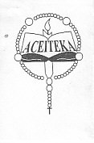
ACEITEKA JOINT MOCK EXAMINATIONS 2015
UGANDA CERTIFICATE OF EDUCATION
GEOMETRICAL DRAWING
PAPER 1
TIME: 3 HOURS

Instructions:
This paper consists of two sections A, and B
Attempt FOUR questions in all. Choose at least two questions from each section.
You are provided with paper size A2. Use both sides for your answers.
The figures in the paper are not drawn to scale.
All dimensions are in millimeters.
No dimension should be indicated on any solution unless otherwise requested.
Unless otherwise, geometrical methods must be used.
Lines that are parallel, perpendicular or inclined to 30º, 45º and 60º to other lines may be drawn without showing construction lines.
SECTION A:
Attempt only two questions.
- (a) Construct a plain scale of 5:2, to read up to 60mm.

(b) Using the scale in (a) above, construct a triangle when given the perimeter as 55mm and altitude as 18mm, 30 vertex angle

- (a) Construct the locus of point A when the pentagon shown rolls without slipping for one revolution along surface XY.

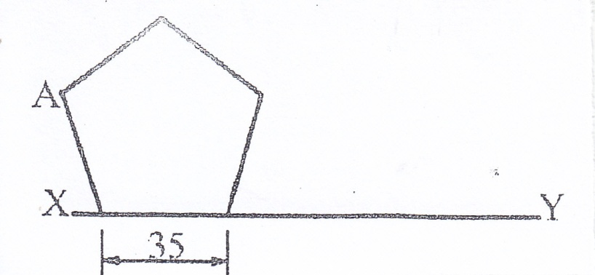

(b) Construct the path taken by the end B of the thread when wound around the given shape whilst keeping the thread taught. Name the path traced.
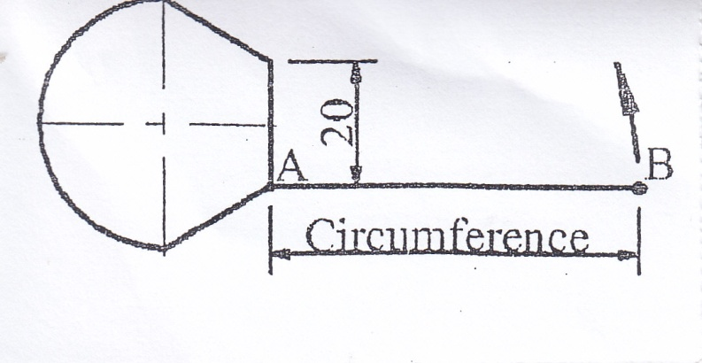

- The figure below shows a pin-jointed mechanism in which crank OA rotates about O through one revolution as end C of BC slides along axis PQ from Q to P and back to Q within the same time. Construct the locus of B for that movement. Use a scale of 2:1
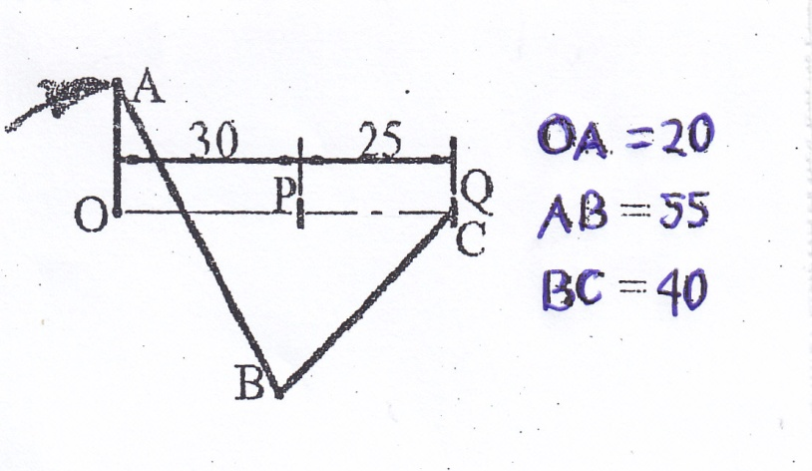
OA = 20
AB = 55
BC = 40
- (a) Construct the figure given below and from it construct a similar figure with its area in the ratio of 3:2
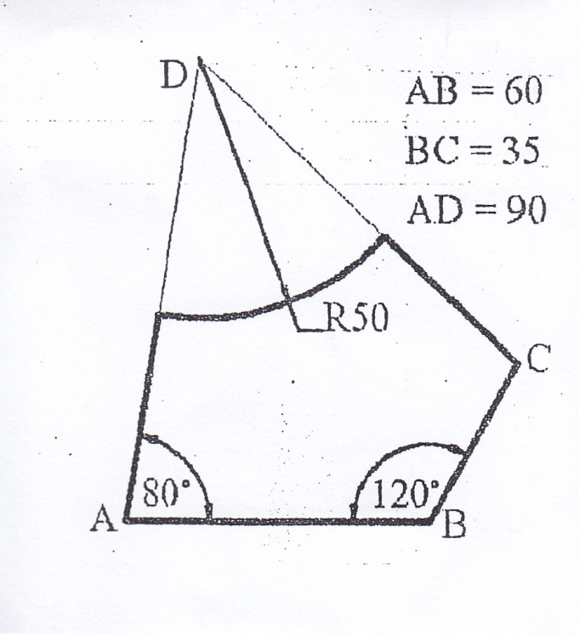

(b) Construct the figure shown below clearly showing how the centre of the dotted circle is obtained.
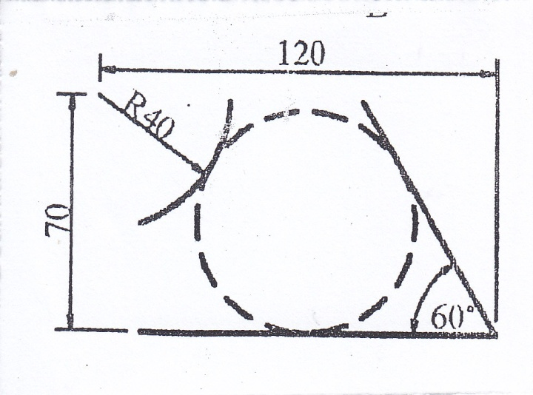

SECTION B:
Attempt only two questions in this section.

- The figure below shows an intersection between a square prism and a cylinder. Draw the given figure and;
- Complete it with the curve of interpenetration
- Develop the surface of the cylinder with the seam at XX.
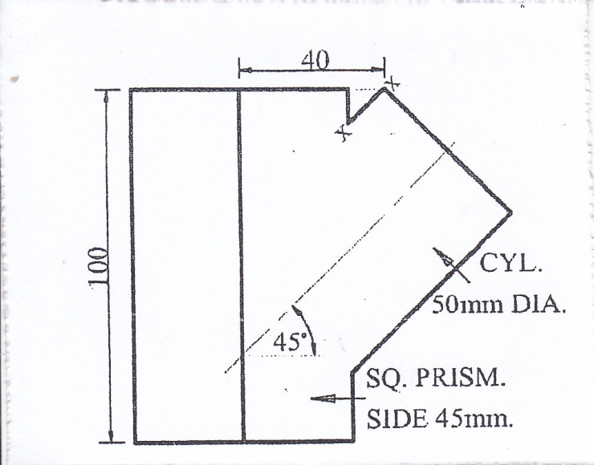

- The figure below shows the front view of a pentagon-based pyramid. Draw the view and in third angle projection construct:
- The end view in the direction of the arrow
- The plan
- The development with the joint line at XX
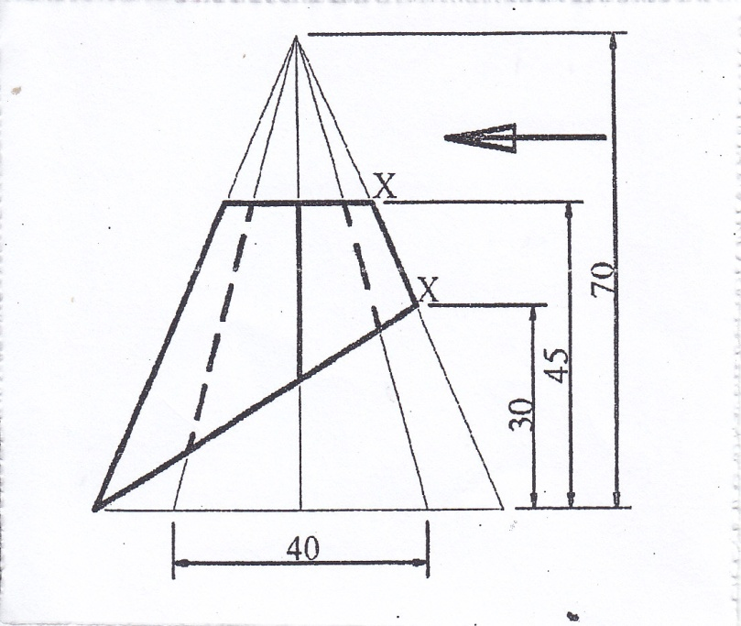
- The figure below shows a shaped block. Draw the given views and determine the auxiliary front view of the block as seen in the direction of arrow A.
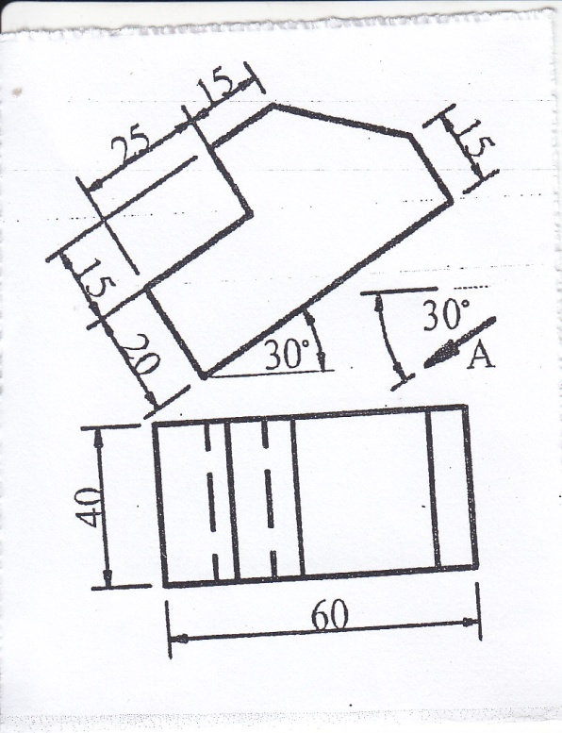

- The figure below shows a lever. Construct the lever in oblique projection with face A closest.
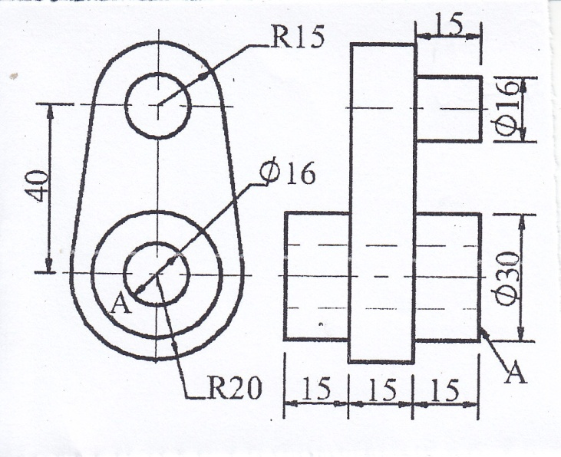

END

